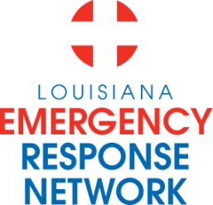

Louisiana Emergency Response Network
Board Meeting
January 16, 2014
2:00pm – 4:00pm
Location: Louisiana Emergency Response Network - Headquarters
14141 Airline Hwy, Suite One, Suite B Baton Rouge, LA 70817

AGENDA
1. Welcome LERN Board Members
2. Roll Call and Establish a Quorum
3. Approval of Agenda
4. Approval of Minutes of 11/21/13 Board Meeting
5. LERN Business:
- Executive Director Report P. Hargrove

b. Ratification of Commission Members P. Hargrove

c. Stroke Medical Director P. Hargrove

d. STEMI Z. Ali, MD

e. 2013 Communication Center Report C. Hector

f. Region 6, 7, and 8 Report D. Spann

g. Budget/Finance P. Sullivan/C. Barr
h. LERN Medical Director Report R. Coscia, MD

i. Dr. McSwain Report/Closing Remarks N. McSwain, MD

j. Election of Officers C. Slaughter

6. Public Comment
7. Adjournment

Next Board Meeting – March 20, 2014 @ the LERN Office 2pm – 4pm

